1) Find out if the given number is an Armstrong number.

Logic:- if 153 is the Supplied value, then 1³+5³ +3³ = 1+125+27 = 153 This is the same as supplied value hence it is an Armstrong number.

**public** **class** Amstrong {

**public** **static** **void** main(String[] args) {

// **TODO** Auto-generated method stub

**int** n=153 , len=0;

**int** t1=n;

**int** arm=0;

**while**(t1!=0) {

t1=t1/10;

len=len+1;

}

**int** t2=n;

**while**(t2!=0) {

**int** mul=1;

**int** rem=t2%10;

**for**(**int** i=1; i<=len; i++) {

mul=mul*rem;

}

arm=arm+mul;

t2=t2/10;

}

**if**(arm==n) {

System.***out***.println(n+ " is an Amstrong number");

}

**else** {

System.***out***.println(n+"is not an Amstrong number");

}

}

}

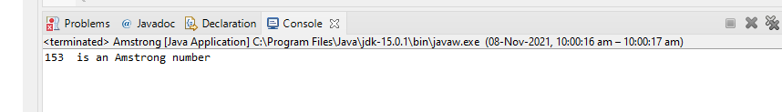

2) Find out all the Armstrong numbers falling in the range of 100-999

**import** java.util.Scanner;

**public** **class** ArmstrongNumber {

**public** **static** **void** main(String[] args) {

Scanner sc =**new** Scanner(System.***in***);

**int** a=sc.nextInt();

**int** b=sc.nextInt();

*findArmstrong*(a,b);

}

**static** **void** findArmstrong(**int** a , **int** b) {

**for**(**int** i=a; i<=b; i++) {

**int** num=i;

**int** sum=0;

**while**(num!=0) {

**int** remainder=num%10;

sum=sum+(remainder*remainder*remainder);

num=num/10;

}

**if**(sum==i)

{

System.***out***.println(sum);

}

}

}

}

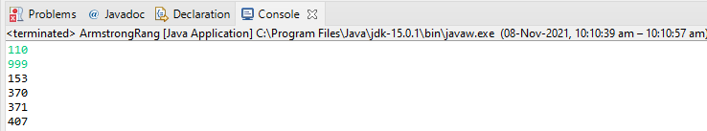

2) Find out all the Armstrong numbers falling in the range of 100-999

**import** java.util.Scanner;

**public** **class** SimpleCom{

**public** **static** **void** main(String[] args) {

**int** p=3000;

**int** r = 4;

**int** t = 10;

;

**int** SI=0;

**double** CI=0;

SI= (p * r * t)/100;

System.***out***.println("SI is : "+ SI);

**int** n = 12;

**double** T=0.05;

CI = Math.*pow*(1+ (t/n),n*t) * p;

System.***out***.println("CI is : "+ CI);

}

}

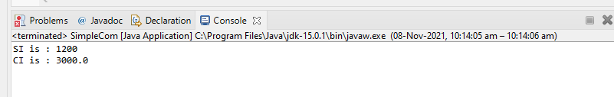

4) Supply marks of three subject and declare the result, result declaration is based on below condit

Condition 1: -All subjects marks is greater than 60 is Passed

Condition 2: -Any two subjects marks are greater than 60 is Promoted

Condition 3: -Any one subject mark is greater than 60 or all subjects' marks less than 60 is failed.

**import** java.util.Scanner;

**public** **class** Result {

**public** **static** **void** main(String[] args) {

// **TODO** Auto-generated method stub

Scanner sc = **new** Scanner(System.***in***);

**int** a = sc.nextInt();

**int** b = sc.nextInt();

**int** c = sc.nextInt();

**if**(a>60 && b>60 && c>60)

{

System.***out***.print("Passed");

}

**else** **if**(a> 60 && b>60 && c<60 || a> 60 && b<60 && c>60 || a<60 && b>60 && c>60 )

{

System.***out***.print("Promoted");

}

**else**

{

System.***out***.print("Failed");

}

}

}

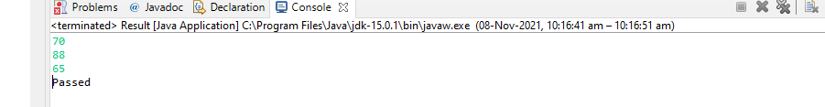

5.

**import** java.util.Scanner;

**public** **class** IncomeTax {

**public** **static** **void** main(String[] args) {

Scanner sc = **new** Scanner(System.***in***);

**int** n = sc.nextInt();

**double** tax =0;

**if**(n>=0 && n<=180000)

{

System.***out***.print("Nil");

}

**else** **if**(n>=181001 && n<=300000)

{

tax = (n * 0.1);

System.***out***.print(tax);

}

**else** **if**(n>=300001 && n<=500000)

{

tax = (n * 0.2);

System.***out***.print(tax);

}

**else**

{

tax = (n * 0.3);

System.***out***.print(tax);

}

}

}

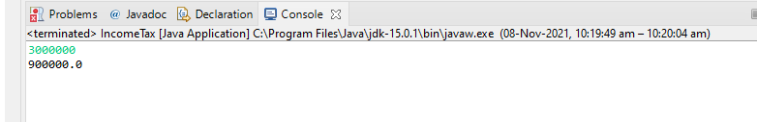

6 .Consider a CUI based application, where you are asking a user to enter his Login name and password, after entering the valid user-id and password it will print the message "Welcome" along with user name. As per the validation is concerned, the program should keep a track of login attempts. After three attempts a message should be flashed saying "Contact Admin" and the program should terminate.

**import** java.util.Scanner;

**public** **class** CUI{

**public** **static** **void** main(String[] args) {

Scanner sc= **new** Scanner(System.***in***);

String name = **null** ;

**int** flag =0;

**for**(**int** i=0;i<3;i++)

{

System.***out***.println("Enter Login Name: ");

name = sc.nextLine();

System.***out***.println("Enter Password: ");

String pass = sc.nextLine();

**if**(!name.isEmpty() && !pass.isEmpty())

{

flag =1;

**break**;

}

}

**if** (flag==1)

{

System.***out***.println("Welcome, "+name);

}**else**

{

System.***out***.println("Contact Admin");

}

}

}

